|  |
| --- |
| Circle Language Spec: Events |

## Events Loose Ideas

The texts below are loose ideas yet to be turned into good documentation.

Activity / Status Events,

~ 2007

I actually have not yet made many events about system activity with a start point and end point. I've merely used data events and interaction events.

I may create a property containing the status of an activity and create a data changed event and maybe a separate data event for each possible value the property gets. That gives us the system activity events.

JJ

Event Connectors,

2011-02-12

Better notation for event connectors:

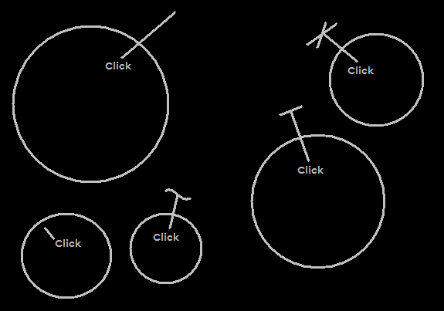

It does (almost) conflict with the notation for comment:

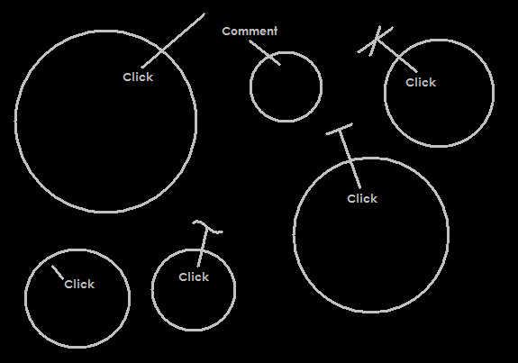

The notation for comment also looks like a good notation for event connectors.

Ofcourse you can easily disambiguate: either set the rule that comment has an inward lne, while events have an outward line. Notation however should go regardless of the placement of a name, so if you ignore the names, the notations do indeed conflict. Then there is the second option to disambiguation: always show the public of friend access mark and in case of private either show an explicit private access mark, or for an explicitly private notation, keep the event connector line inside the container (the lower-left notation).

So this gives adequate solutions for a unambiguous notation.

JJ